**Saturday, April 6**

**10am – 1pm**

**St. Paul Wellness Fair 2019**

**181 Elm St E. Longmeadow, MA**

**FEATURING:**

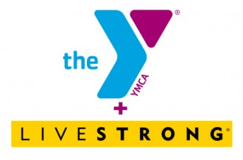

**Blood Drive: April 25**

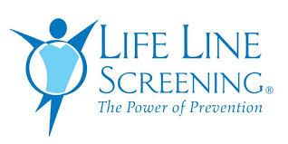 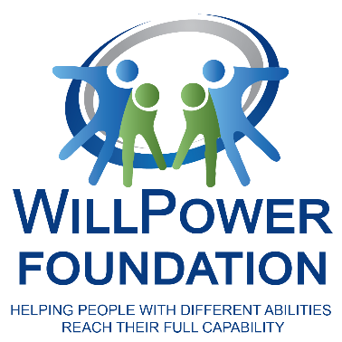 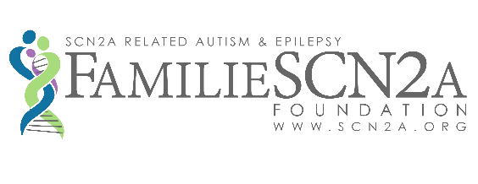

**Screenings: August 12**

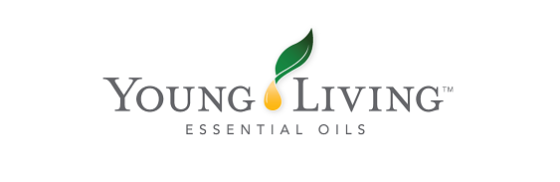

**New Beginnings**

**Chiropractic For More Info: (413) 525-6084**